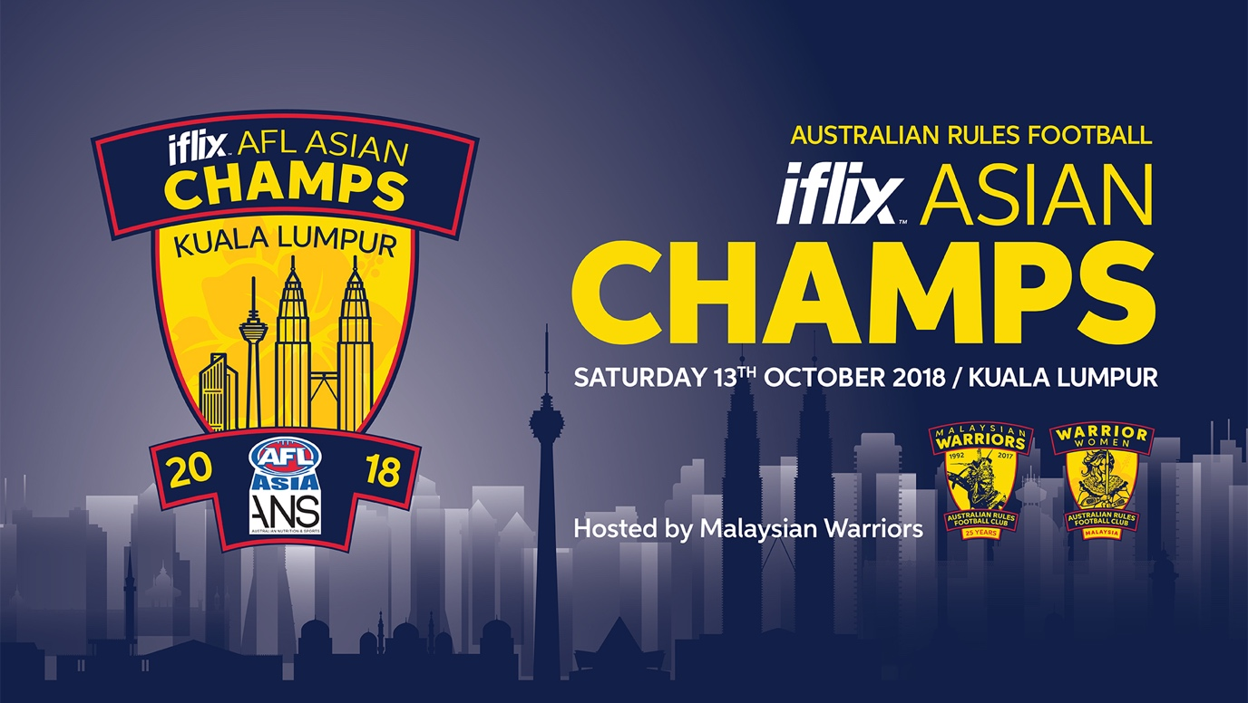

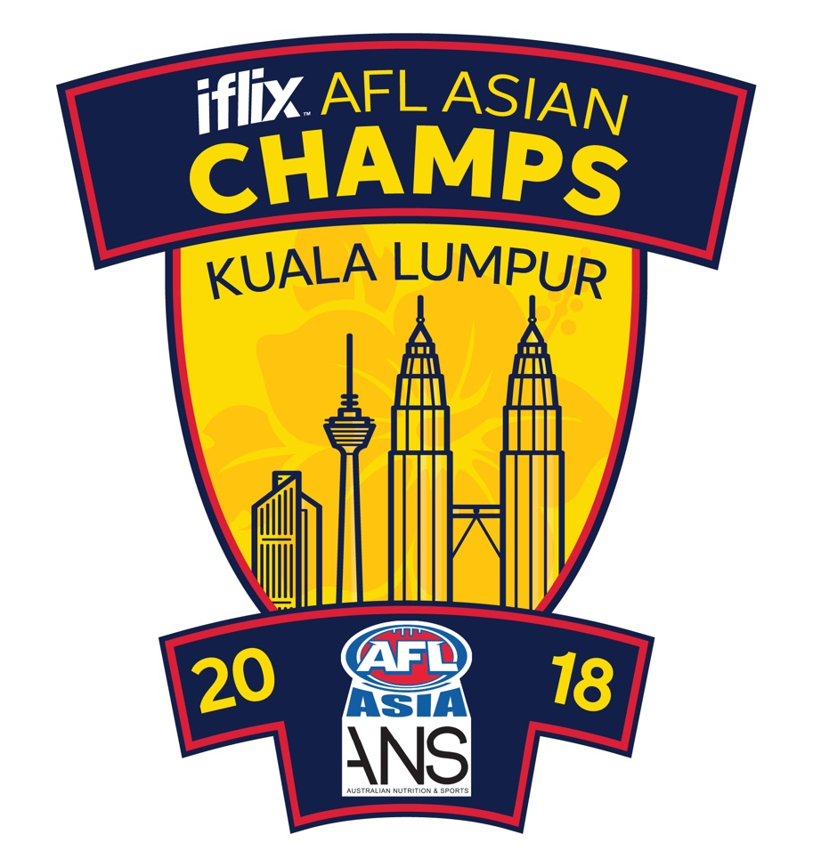

1. **Welcome to the 2018 AFL Asia Championships**

The Malaysian Warriors Australian Rules Football Club warmly welcome competing teams, family, friends and spectators to the 19th AFL Asian Champs! This year’s event is set to be the largest Asian Champs in the history of the tournament with a record 22 teams registered to participate.

As Australian Rules football continues to grow across the region we’re excited to be hosting this year’s Champs and look forward to a huge weekend of Aussie Rules at its Asian finest.

This document is the ‘Event Prospectus’ and will detail information on the hosting and logistics of the Asian Champs.

A separate document covering Rules and Regulations will be drafted and circulated by AFL Asia.

1. **Overview**

The 2018 Asian Champs will be held in Kuala Lumpur, Malaysia for the 3rd time in the 19 year history of the Champs, having previously played host to the 2004 and 2009 tournaments.

22 teams have registered their interest in participating which will be spread across Division 1 with 7 teams, Division 2 which will see a record 11 teams and for the first time a Women’s Division consisting of 4 teams.

In preperation for this year’s event the Malaysian Warriors Organising Committee surveyed all AFL Asia member clubs and sought feedback on what made for a great experience at Champs, what club’s valued, what worked well at previous Champs and of course what was not so good. In summary the key pieces of feedback received was:

* Playing time for teams – ensure 4 pool games.
* Improve scheduling to avoid late finishes
* Increase number of playing ovals to 3
* Improve quality of playing surface
* Increase size of oval for Division 1 (16 a side)
* Timely transport to and from the playing venue
* Quality food and beverages available

With this feedback in hand we’re pleased to advise that with the increased number of teams the Champs venue will for the first time comprise 3 playing ovals at the Bukit Kiara Equestrian Centre in Damansara Heights; ensuring a high quality playing surface, enable improved scheduling, a larger oval for Division 1 and located only 15 to 20 minutes from the centre of Kuala Lumpur.

1. **Organising committee**

The Malaysian Warriors Organising Committee members are as follows:

* James Symons – Champs Project Manager email: [champs2018kl@gmail.com](mailto:champs2018kl@gmail.com)
* Josh Leary
* Hayley Leary
* Corey Weekes
* Kurt Stocks
* Shaun Di Gregorio

1. **Friday Night President’s Meeting**

A regular feature of Champs is an AFL Asia Club Presidents meeting, with this year’s get together being held on Friday October 12th, 7 pm with the venue TBC. All Clubs please ensure that a representative is in attendance as it is the only occasion for the year where we’re all in the one place and important matters are discussed, debated, argued and eventually voted on. Please note; only one representative can vote of behalf of their Club.

1. **Ground Location**

This year’s Champs will be held at the magnificent ‘Bukit Kiara Equestrian and Country Resort’, just a short 15 to 25 minute drive (12 kms) from Bukit Bintang, where most teams will be staying. For players/spectators wishing to arrange their own transport (outside the team buses which will be provided) direct taxis/GRAB cars to “Bukit Kiara Polo.”

Bukit Kiara Polo Field

Jalan Bukit Kiara, Bukit Kiara, 60000 Kuala Lumpur, Wilayah Persekutuan Kuala Lumpur

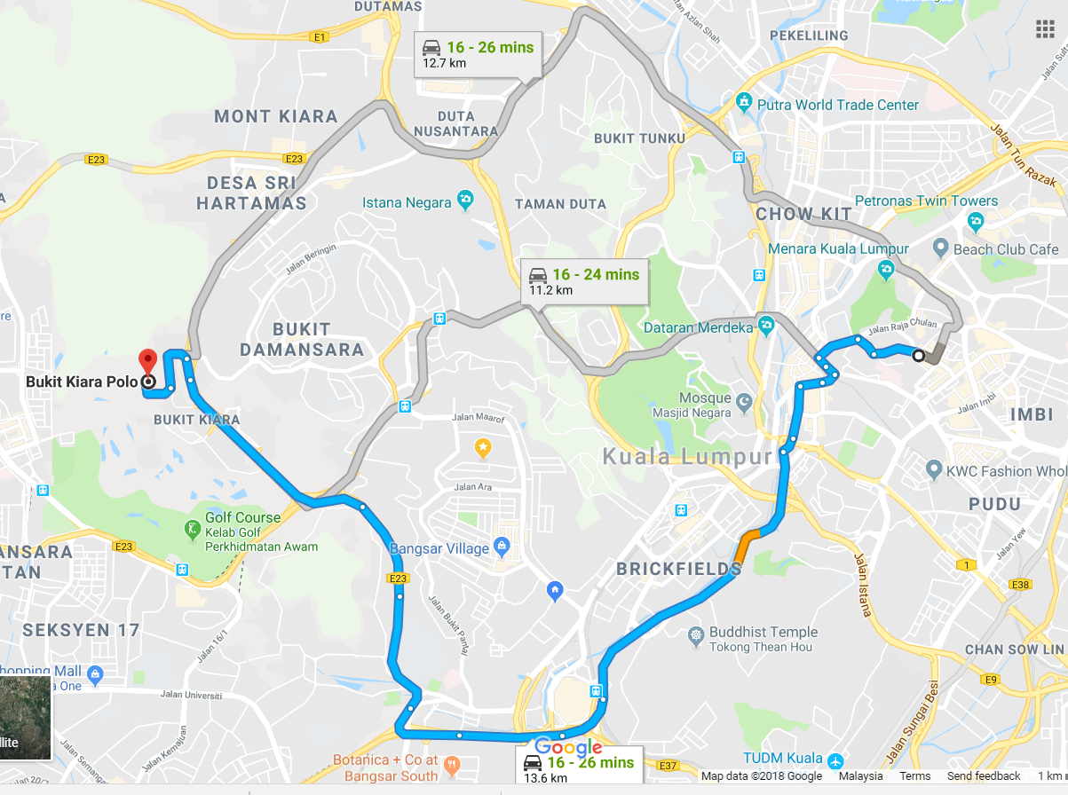

Route shown from Havana Bar & Grill to Bukit Kiara Polo Field

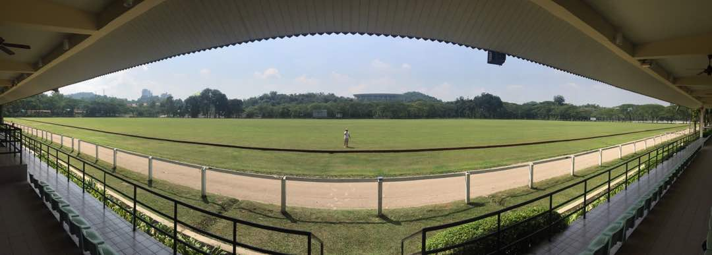

1. **Ground layout**

For the first time the Asian Champs will be played across 3 ovals. The layout will also feature:

* Pavilion and Grandstand for match official, umpires & VIP bar
* Multiple food vendor stations, water stations and bars
* Additional canopies for playing teams interchange bench
* Designated warm-up areas for all teams

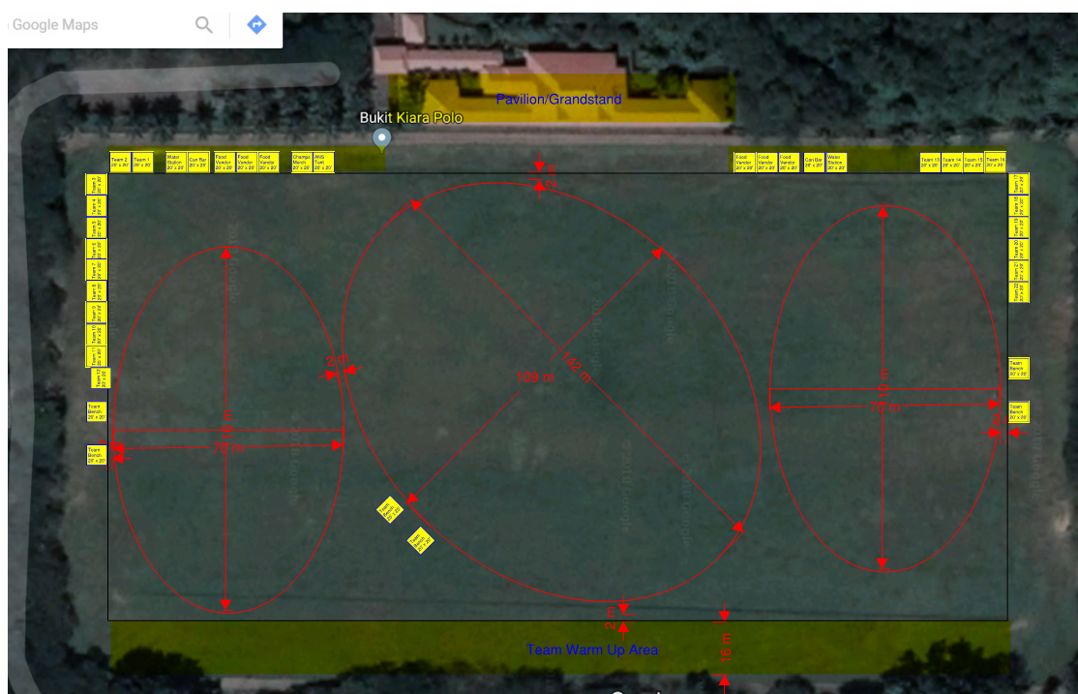

1. **Tournament Fees**

This year’s tournament fees have been kept the same as previous years:

* Division 1 – US$1,400 per team
* Division 2 – US$1,200 per team
* Women’s – US$800 per team

Banking details will be provided by the organising committee directly to each participating Club. Entry fees must be paid ahead of the tournament date with a very simple rule – no pay, no play.

* All participating Clubs MUST first be paid up members of AFL Asia.

1. **2018 Competing Teams**

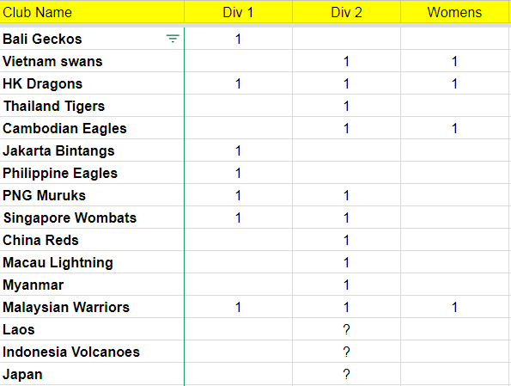

1. **Tournament details**

**Duration of games**

* Pool games will 2 x 12 minute halves with a 3 minute half time break
* Finals will be 2 x 15 minute halves with a 5 minute half time break

**Start times**

Games will be scheduled in 30 minute blocks with all fields starting and finishing halves at the same time.

Teams will need to be ready to take the field immediately following the preceding game as tight scheduling will again be a feature of the day. The changeover between games will be 3 minutes allowing teams to clear the field following their game and the new teams to take their starting positions.

A centrally controlled siren will sound on the designated start and end times for all grounds. The game will officially start when the Umpire blows the whistle and then bounces the ball. Be in position ready to go or be prepared to look like a goose and the butt of jokes to your team mates and opponents alike.

**1 minute rule and ‘no-show’ penalties**

If a team is not ready to go and in position once the siren has sounded to start play, a penalty of 1 goal per minute will apply until the offending team take the field of play. The penalty of 1 goal per minute will be applied up for to 12 minutes or 72 points. If both teams are not in position the penalty will commence once the first team takes the field of play.

If by half time a team still hasn’t shown up the game will be awarded to the team on the ground up to a maximum of 72 – 0. The central umpire will be responsible for managing and ruling on any infringement.

**Overtime**

If a pool game ends in a draw it shall stand.

Semi-finals & Finals – TBA

**Coin toss**

The Captain (or Club representative) of each team must attend the Match Officials area at half-time of the preceding game where the coin toss will take place by the designated umpire or tournament official. Team sheets must also be submitted at this time.

*If you are approached by a shady looking person offering to ‘fix’ the coin toss result, or any other results for that matter, please ignore them as this is match fixing and that’s best left to the cricketers.

**Numbers of players**

Division 1

16 players on the field and a maximum of 10 on the interchange bench for a total squad size of 26 per game

Division 2

12 players on the field and a maximum of 8 on the interchange bench for a total squad size of 20 per game

Women’s

12 players on the field and the interchange shall be uncapped. A “barbarians” team can be formed if there is sufficient additional players.

1. **Sample draw**

The Warriors will conduct a live draw prior to champs (broadcast on Facebook) once the competing teams have been confirmed. *Sample draw only* – teams will not play any back to back games.

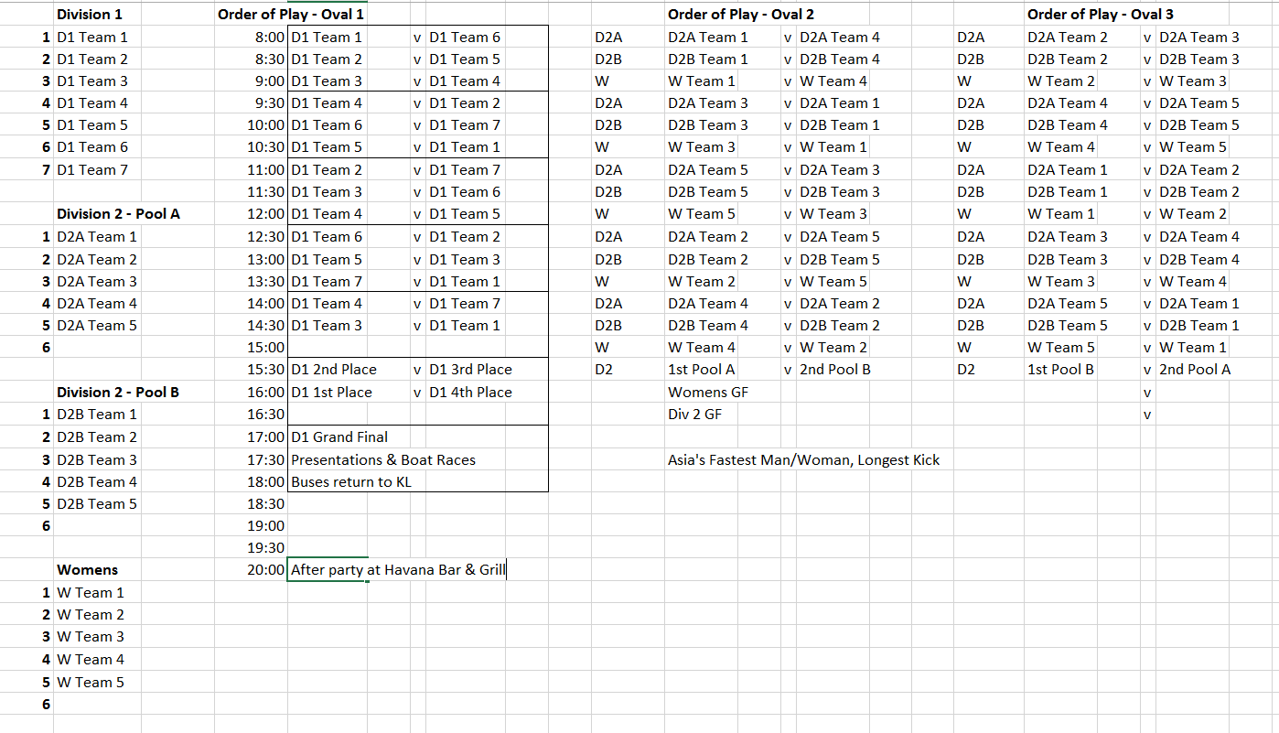

1. **Travel and accommodation**

Kuala Lumpur is well served by airlines with direct flights by low cost carrier Air Asia, as well as Malaysian Airlines. There are direct flights into KL from all participating team’s locations with the exception of PNG (via Singapore)

See Travel and Accommodation Guide – provided separately.

Visas

Australian passport holders do not require a Visa to enter Malaysia and are entitled to a 90 day stay as a tourist.

Other Nationalities should check with their local consular representatives or reference online resources such as here:

<https://en.wikipedia.org/wiki/Visa_policy_of_Malaysia#Visa_free>

1. **Player and team Registration**

Teams will be required to provide a team sheet with players listed as in previous years. Team sheets will be forwarded separately to clubs.

1. **What each team needs to do at Champs**

Each team is required to nominate a team manager, please forward their email to [champs2018kl@gmail.com](mailto:champs2018kl@gmail.com). This is to facilitate the organisation of team buses, player registration, etc.

Each player will be provided with a player pack containing some useful items for the day at champs including a water bottle. There will be water stations around the ground and each team/player will be responsible for filling their own water bottles up when required.

Team will be required to submit a list of goal kickers following each game (if they wish their player to be a chance at winning the leading goal kicker award).

1. **Boundary Umpires & On Day Assistance**

Field, boundary and goal umpires

All umpiring matters will be managed by AFL Asia. Clubs will receive an invitation from AFL Asia for anyone who is interested in assisting with umpiring on the day.

As is convention Clubs will be required to provide assistance with boundary and goal umpiring and there will be more information provided on this as we get closer to the date of the Champs.

1. **Asian Championships Awards**

The following awards will be presented after the Grand Final:

* Asian Championship Cup to the winners of each Division
* Player of the Final for each Division
* Leading overall goal kicker
* ‘All Asian Team’ representatives

1. **Saturday night Function**

On the Saturday night after the match day festivities have concluded there will be an ‘After Party’ at Havana Bar and Grill on Changkat Bukit Bintang from 8 pm, an easy stroll from where most teams will be staying.

Havana is a huge venue and we’ve secured exclusivity for the entire upstairs area from 8 pm to 11 pm, after which teams can wander off into the night and enjoy all that KL has to offer.

To give the night some gravitas the Malaysian Warriors will be donating profits from the sale of alcohol during the day and purchasing Tiger beer barrels at Havana with the proceeds.

We’ll turn the barrels on at 8 pm sharp and provide all participating players from AFL Asia clubs ‘FREE BEER’ until the barrels run out.

Yes that’s right, FREE BEER until the barrels run dry. Wrist bands will be provided on the day and must be worn for entry to Havana. Our best advice is get to Havana bang on 8 pm!

1. **Other Information**

Money

The local currency in Malaysia in the Ringgit which converts to the AUD at ~ RM3 : AUD1. ATMs are plentiful and most bars, restaurants and retail outlets accept credit and or debit card payments.

Climate

Malaysia is a tropical climate with consistently warm temperatures all year, in the range of 22°C to 31°C. Humidity is high at around 80% with average rainfall of 272 mm for the month of October.

There are two main seasons in Malaysia; 1) hot and; 2) hot and wet. October is generally hot with some rainfall.

Day light hours

During the month of October daylight hours are generally 7 am to 7 pm allowing for plenty to manage a busy Champs schedule.

Hospital

Medical care in Malaysia is of a very high standard with large modern hospitals located within a short distance from the playing venue.

Ambulances will be onsite at the playing venue to care for any injuries.

Insurance

It is important to note that teams are responsible for obtaining their own player/travel insurance as required.